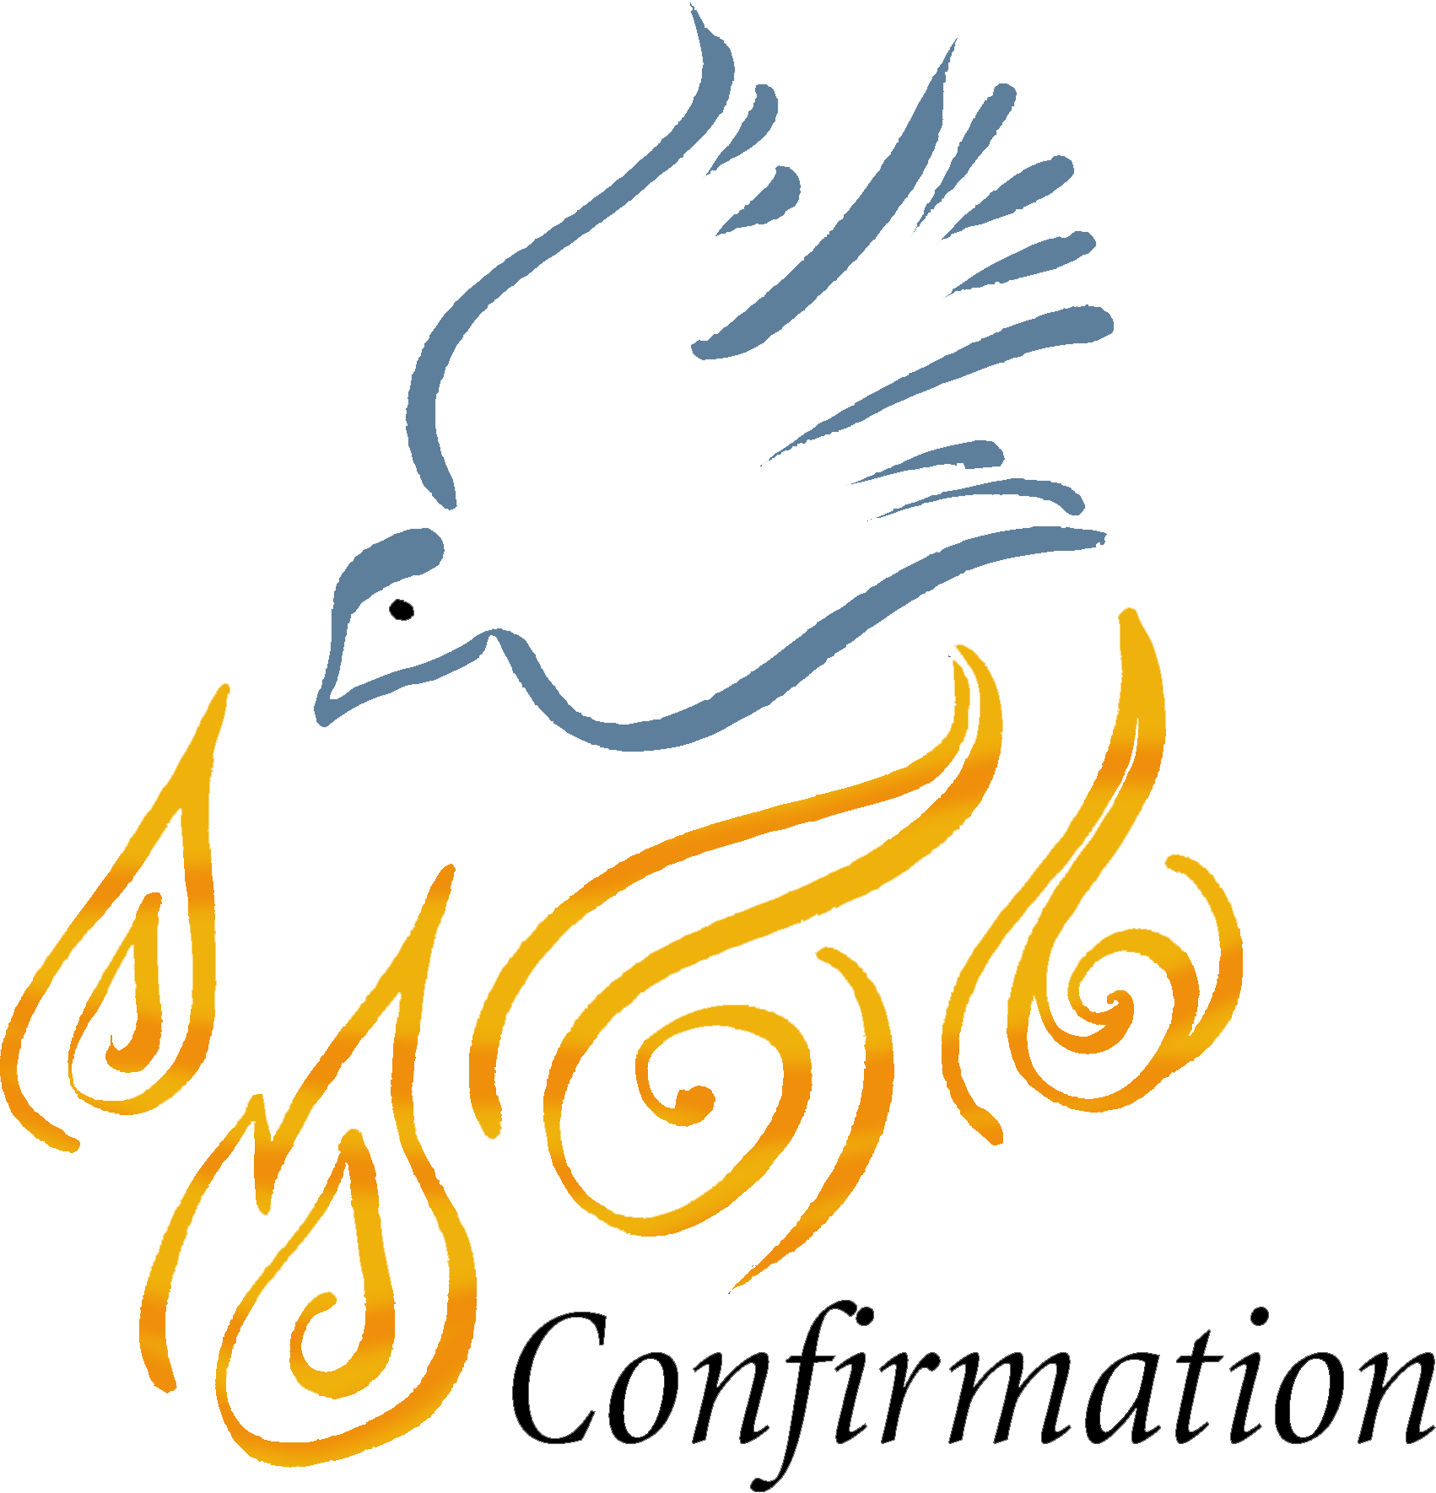

Important Dates for 2017/2018 school year:

The following Decision Point sessions are mandatory for all Confirmation candidates, so please mark your calendars:

Session duration: 4:45-6:45 pm, followed by Mass at 7 pm. Refreshments will be provided.
Session location: St. Bernhard’s church, Königin-Luise-Str. 33, Berlin-Dahlem

September 10 | Life is Choices | Confirmation mentors are asked to attend this session
September 17 | 4:25-4:45 pm: Scheduling Session for YDisciple groups!  4:45-6:45 pm: What’s Holding You Back | Parents and group members need to attend!  Parent meeting (with Fr. Sylvester) + Opening Mass at 7 pm
September 24 | The Jesus Question
October 15 | Prayer
November 12 | The Bible
December 3 | Relationships
January 21 | The Eucharist
February 18 | The Church
February 25 | Holy Spirit / Holiness is Possible
March 4 | Made for Mission
March 18 | Confirmation
April 14 | Confirmation Retreat | Time & location TBA
April 15 | CONFIRMATION | 11 am Mass, St. Bernard’s

Note: 2 sessions can be missed, but will need to be made up via homework and a quiz. YDisciple sessions are separate and will continue. Regular attendance at YDisciple sessions will also help make up missed Decision Point sessions.

Where to get information on homework:

After each session, we will post the homework assignments on the Mission website:

www.english-mission-berlin.de

Look for the “Decision Point” tab. The homework for those who have missed a lesson and for those who were in attendance can be found there, including the links to stream the content videos.
The video content is also in the books themselves, so if the candidate prefers to read instead of watching the videos, s/he will not miss anything.

YDisciple groups:

The Decision Point sessions include 25 + (!) candidates. Therefore, it is not possible to go into much of the content at a very deep level. It is ESSENTIAL that the youth continue to attend the small-group YDisciple sessions with their mentors from last school year. The integration of the content presented in Decision Point and YDisciple sessions requires the in-depth discussions and personal dimension facilitated by the small groups. In addition, small groups will continue to address topics of interest to the group which are NOT covered in Decision Point.

Service projects:

Each candidate is expected to live their Christian vocation to serve both WITHIN the Church as well as OUTSIDE the Church. The YDisciple groups will be a forum within which service projects are organized and discussed.
- Service within the Church:
  - Each YDisciple group is expected to organize and host ONE catechetical event for younger kids within the ESM. These will be intergenerational or focused on a particular age group. The assignments are as follows:
    - All Saints Girls group – GIMN intergenerational event (for lower elementary kids) on MARY 7 Oct @ All Saints
    - All Saints Boys & St. Bernard’s Boys – EDGE Night “Buddy System” on the topic of true friendship (for middle schoolers, 6-8 graders). @St. Bernard’s, DATE TBA.
    - St. Elizabeth’s Co-Ed Group – GIMN intergenerational event on PENTECOST. @ St. Elizabeth’s, DATE TBA.
- Service outside the Church:
  - Soup kitchen with the Missionaries of Charity in Kreuzberg (3 candidates + mentors).
  - Projects with refugees (consult with Dirk)
  - Other ideas?

